

**100D Barber**

|  |  |  |
| --- | --- | --- |
| **Supervisor:** | *LÊ THANH NHÂN* | |
| **Semester:** | *II* | |
| **Batch No:** | *T1.2209.M0* | |
| **Group No:** | *02* | |
| **Order:** | **Full name** | **Roll No.** |
| *1.* | *Lý Khánh Hưng* | *Student1420710* |
| *2.* | *Dương Tuấn Kiệt* | *Student1420699* |
| *3.* | *Phạm An Hào* | *Student1416036* |
| *4.* | *Trương Hoàng*  *Nguyên* | *Student1418253* |

***Month****: 7* ***Year****: 2023*



This is to certify that

|  |  |
| --- | --- |
| **Mr.** | **LÝ KHÁNH HƯNG** |
| **Mr.** | **DƯƠNG TUẤN KIỆT** |
| **Mr.** | **PHẠM AN HÀO** |
| **Mr.** | **TRƯƠNG HOÀNG NGUYÊN** |

Have successfully Designed & Developed

|  |  |  |
| --- | --- | --- |
|  |  |  |
| **100D Barber** | | |

Submitted by:

|  |
| --- |
| **Mr. LE THANH NHAN** |

Date Of Issue:

|  |  |
| --- | --- |
|  |  |

Authorized Signature:

|  |  |
| --- | --- |
|  |  |
| **Content** | | | |

Content

Acknowledge

Synposis

Review1 4

Review2 22

Review3 6

Testting Document 1

Final Checklist 1

Tasksheet 1

|  |
| --- |
| **Acknowledge** |

As we understand that the eProject is a step-by- step learning environment that

closely simulates the class-room and Lab based learning environment into actual

implementation. It is a project implementation at your fingertips!! An electronic, live

juncture on the machine that allows you to.

✓ Practice step by step i.e. laddered approach.

✓ Build a larger more robust application.

✓ Usage of certain utilities in applications designed by user.

✓ Single program to unified code leading to a complete application.

✓ Learn implementation of concepts in a phased manner.

✓ Enhance skills and add value.

✓ Work on real life projects.

✓ Give a real life scenario and help to create applications more complicated

and useful.

✓ Mentoring through email support.

We would like to send a great thank to our professor and others student for the

adorable supports during the time in project.

Beside several mistakes we had made in the project, we hope to have more

opportunities to widen our knowledge in web developing world.

We also thank you so much for your information and the “demo” project from India

APTECH to help us get more reality experience in this project. Since we have gained

more experience from this project, we will not stop learning any thing as much as we

can to be more successful in the future.

Your Sincerely,

Team Group 02.

|  |
| --- |
| **Synopsis** |

The Objective of this program we aim is to give a sample project to work on real life projects. These applications help us build a larger more robust application.

The objective is not to teach us front-end or back-end technology but to provide us with a real life scenario and help us create basic applications using the tools.

Hence, we can revise the chapters before we start with the project.

This project is meant for students like us who have completed the module of

Semester II, as well as special subjects those are Java and PHP. These programs should be done in the Lab sessions with assistance of the faculty if required.

The website (in this project) is a barber shop website.

It is very essential for us that will have a clear understanding of the subject. We

think we should go through the project and solve the assignments as per requirements given

**Review 01**

|  |
| --- |
| **Problem Definition** |

Our client owns an up-and-coming barbershop and wants to move it to the next level. The only way to get a haircut at the shop is to walk in and wait up to 1-2 hours for a haircut on a busy day which has caused many customers to be impatient and leave. The client wants to be more efficient with scheduling customer appointments, which will lead to better customer service. To boost efficiency and the customer experience, our client contacted us to help them develop a website. The main goal of this project is to allow a portal for customers to make appointments on the Internet, saving time and making the shop more organized. Other goals of this project are increased customer traffic due to the new online presence and broader communication to potential customers on services and prices. The client has also requested that their work is shown with customer reviews to establish authenticity.

Based on the need stated in the Project Overall, we design an application that will provide the key features and functionalities as the followings:

✓ Provide function for customers register.

✓ Provide function for customers to booking services.

✓ Provide information of the product to customers.

✓ Provide shopping cart function so customers can order products.

✓ The customers can manage their information by Member Control Panel (MCP).

✓ Receive rating from customers to improve service quality as well as product quality.

An Admin Control Panel (ACP) that support about management system:

✓ Administrators the ability to add, update product and employee information quickly and accurately.

✓ Administrators the ability to manage customers and view their order and rating.

The Role of User and Admin:

1. User:

✓ Can register as a member and manage personal account.

✓ Can book services.

✓ Can view and buy products.

✓ Can rate about products.

✓ Can view their orders.

2. Administrator

✓ Can add / edit / deactivate products and categories.

✓ Can view customer’s information or deactivate an account.

✓ Can add / edit / delete employees.

✓ Can view all orders and rating.

|  |
| --- |
| **Customer Requirements Specifications** |

**User:**

**Input:**

- Member registration data.

- View product’s data.  
- Order selected products.  
- Rating about products/employees.

**Process:**

- Search products from database by categories, by product types.

- Process customer registration data.  
- Process product’s rating.  
- Process customer orders (services/products).

**Output:**

- Notification of successful registration / failure.

- Product information.  
- Notification of successful making order (services/products).

**Webmaster:**

**Input:**

- Administrator login data .  
- Product and employees data to add / edit / delete.

- Member data to be search / delete.  
- Order data to view.

**Process:**

- Add / edit / delete products/employees.  
- View data of all members.

- View all orders.

**Output:**

- Notification to add / edit / delete - products/employees - success / failure.

- Notification to delete members.

**Hardware / software requirement:**

|  |  |  |
| --- | --- | --- |
| Sr. | Item | Description |
| 1. | Operating system | Windows 7, 8 or higher |
| 2. | Hardware | CPU Cores or better with 2 Gigabytes of RAM or better |
| 3. | Web Browser | Version in later of: Edge, Firefox, Chrome, etc… |
| 4. | Fonts | Standard font Unicode: Arial, Tahoma, Times New Roman, etc… |
| 5. | Other requirement | NodeJS, Git, XAMPP 7.3 or later | A working internet connection. |

**Review 02**

|  |
| --- |
| **Data Flow Diagram** |

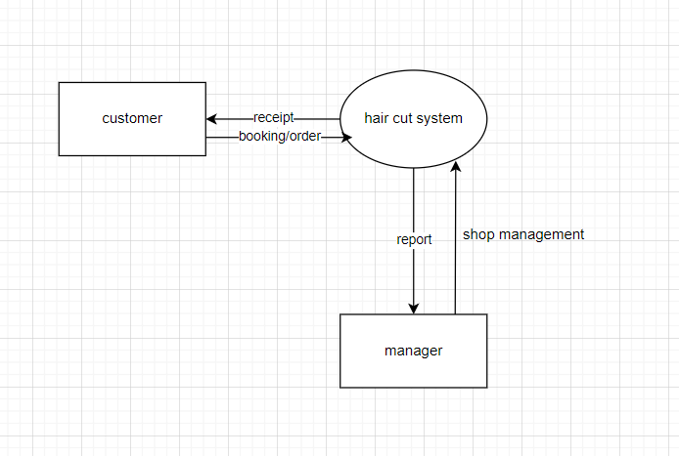

|  |
| --- |
| **A. Entity Relationship Diagram** |

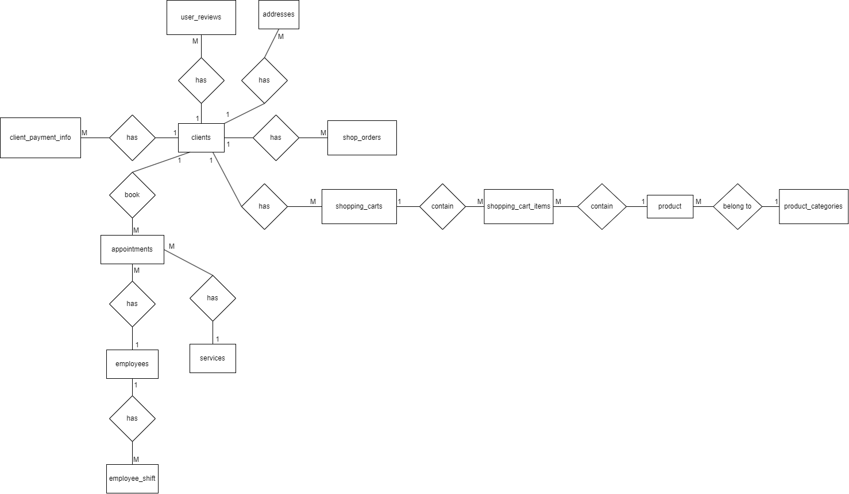

|  |
| --- |
| **B. Entity Attributes** |

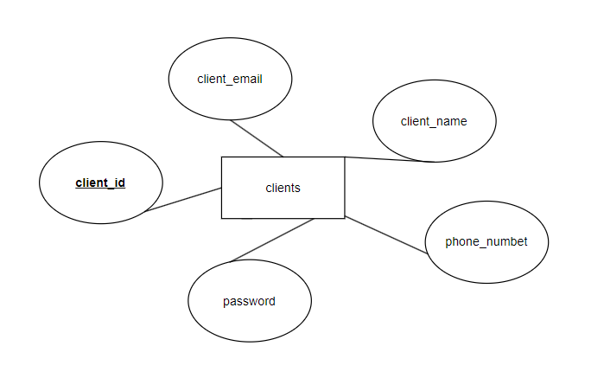

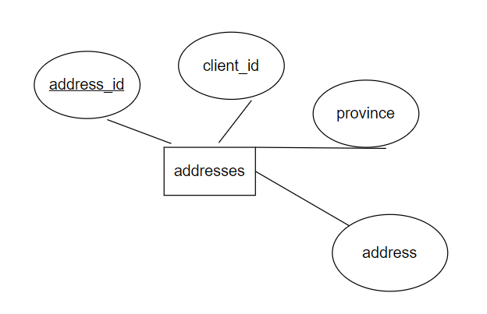

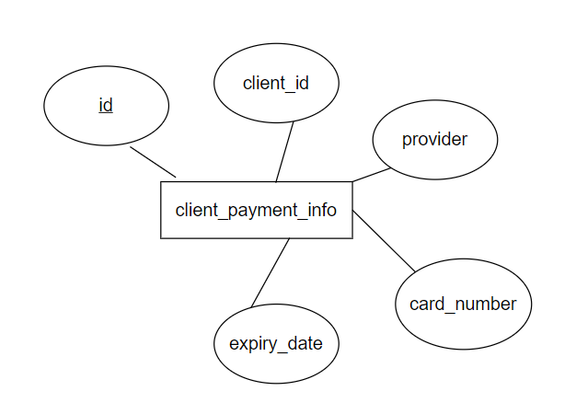

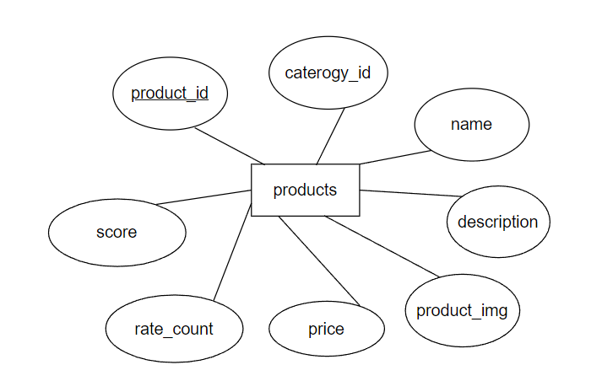

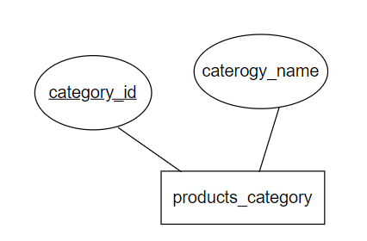

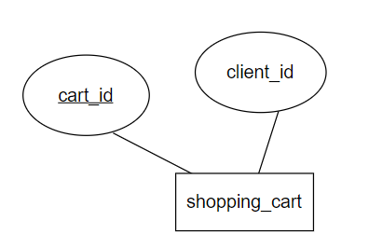

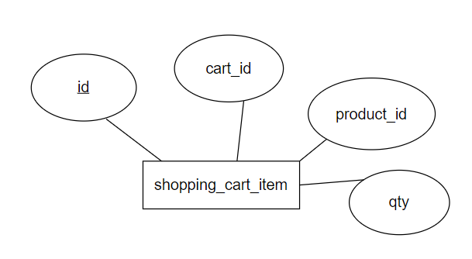

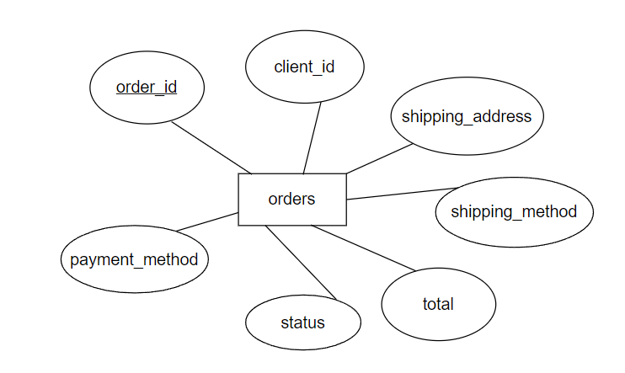

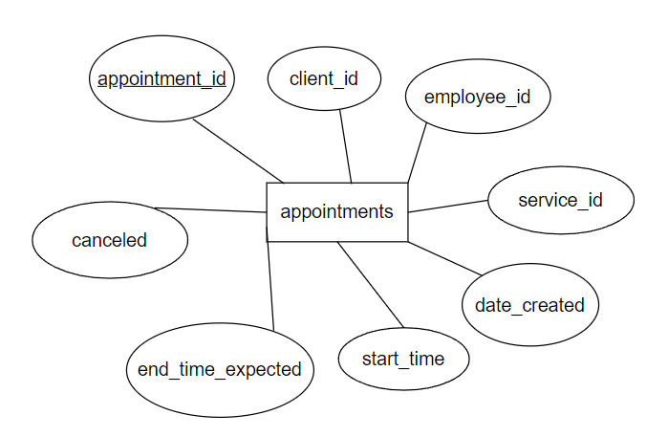

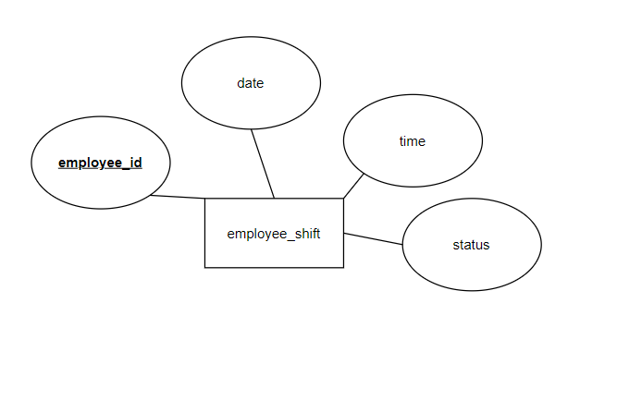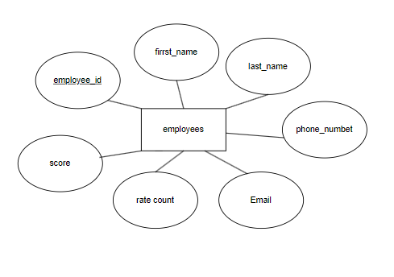

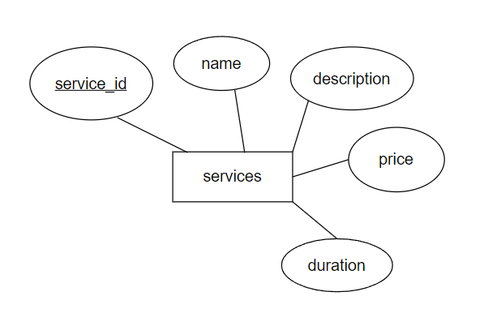

|  |
| --- |
| **A. Table Design** |

|  |  |  |  |  |  |
| --- | --- | --- | --- | --- | --- |
| clients | | | | | |
| Serial | Fields | Data type | Keys | Constrains | Description |
| 1 | client_id | int(5) | Primary key | NOT NULL | Client identification |
| 2 | client_email | varchar(50) |  | NOT NULL | Client’s email |
| 3 | client_name | varchar(40) |  | NOT NULL | Client’s name |
| 4 | phone_number | varchar(30) |  | NOT NULL | Client’s phone number |
| 5 | password | varchar(50) |  | NOT NULL | Password to login |

|  |  |  |  |  |  |
| --- | --- | --- | --- | --- | --- |
| addresses | | | | | |
| Serial | Fields | Data type | Keys | Constrains | Description |
| 1 | address_id | int(50) | Primary key | NOT NULL | Address identification |
| 2 | client_id | Int(50) | Foreign key | NOT NULL | Client identification |
| 3 | province | varchar(100) |  | NOT NULL |  |
| 4 | address | varchar(100) |  | NOT NULL | clients’ detail address |

|  |  |  |  |  |  |
| --- | --- | --- | --- | --- | --- |
| client_payment_info | | | | | |
| Serial | Fields | Data type | Keys | Constrains | Description |
| 1 | id | int(50) | Primary key | NOT NULL |  |
| 2 | client_id | int(50) | Foreign key | NOT NULL | Client identification |
| 3 | provider | varchar(40) |  | NOT NULL |  |
| 4 | card_number | varchar(23) |  | NOT NULL |  |
| 5 | expiry_date | varchar(15) |  | NOT NULL |  |

|  |  |  |  |  |  |
| --- | --- | --- | --- | --- | --- |
| products | | | | | |
| Serial | Fields | Data type | Keys | Constrains | Description |
| 1 | product_id | int(50) | Primary key | NOT NULL | Product identification |
| 2 | category_id | int(50) | Foreign key | NOT NULL | Category identification |
| 3 | name | varchar(100) |  | NOT NULL |  |
| 4 | description | varchar(100) |  | NOT NULL |  |
| 5 | product_image | varchar(100) |  | NOT NULL |  |
| 6 | price | decimal(10,2) |  | NOT NULL |  |
| 7 | rate_count | int(100) |  | NOT NULL DEFAULT 0 | increment by 1 each time a customer rate |
| 8 | score | decimal(10,1) |  | NOT NULL DEFAULT 0 | increment 1 to 5 based on customer rate |

|  |  |  |  |  |  |
| --- | --- | --- | --- | --- | --- |
| product_categories | | | | | |
| Serial | Fields | Data type | Keys | Constrains | Description |
| 1 | category_id | int(50) | Primary key | NOT NULL |  |
| 2 | category_name | varchar(100) |  | NOT NULL |  |

|  |  |  |  |  |  |
| --- | --- | --- | --- | --- | --- |
| shopping_cart | | | | | |
| Serial | Fields | Data type | Keys | Constrains | Description |
| 1 | cart_id | int(50) | Primary key | NOT NULL | Cartt identification |
| 2 | client_id | int(50) | Foreign key | NOT NULL | Client identification |

|  |  |  |  |  |  |
| --- | --- | --- | --- | --- | --- |
| shopping_cart_item | | | | | |
| Serial | Fields | Data type | Keys | Constrains | Description |
| 1 | id | int(50) | Primary key | NOT NULL |  |
| 2 | cart_id | int(50) | Foreign key | NOT NULL | Cart identification |
| 3 | product_id | int(50) | Foreign key | NOT NULL |  |
| 4 | qty | int(20) |  | NOT NULL |  |

|  |  |  |  |  |  |
| --- | --- | --- | --- | --- | --- |
| orders | | | | | |
| Serial | Fields | Data type | Keys | Constrains | Description |
| 1 | order_id | int(100) | Primary key | NOT NULL |  |
| 2 | client_id | int(50) | Foreign key | NOT NULL | Client identification |
| 3 | shipping_address | varchar(100) |  | NOT NULL |  |
| 4 | shipping_method | varchar(50) |  | NOT NULL |  |
| 5 | total | decimal(10,2) |  | NOT NULL |  |
| 6 | status | varchar(30) |  | NOT NULL DEFAULT 'unfinished' |  |
| 7 | payment_method | varchar(50) |  | NOT NULL |  |

|  |  |  |  |  |  |
| --- | --- | --- | --- | --- | --- |
| appointments | | | | | |
| Serial | Fields | Data type | Keys | Constrains | Description |
| 1 | appointment_id | int(5) | Primary key | NOT NULL |  |
| 2 | date_created | timestamp |  | NOT NULL DEFAULT '0000-00-00 00:00:00' |  |
| 3 | client_id | int(5) |  | NOT NULL |  |
| 4 | employee_id | int(2) | Foreign key | NOT NULL |  |
| 5 | start_time | timestamp |  | NOT NULL DEFAULT '0000-00-00 00:00:00' |  |
| 6 | end_time_expected | timestamp |  | NOT NULL DEFAULT '0000-00-00 00:00:00' |  |
| 7 | canceled | tinyint(1) |  | NOT NULL DEFAULT 0 |  |
|  | cancellation_reason | text |  | DEFAULT NULL |  |

|  |  |  |  |  |  |
| --- | --- | --- | --- | --- | --- |
| employees | | | | | |
| Serial | Fields | Data type | Keys | Constrains | Description |
| 1 | employee_id | int(50) | Primary key | NOT NULL |  |
| 2 | first_name | varchar(20) |  | NOT NULL |  |
| 3 | last_name | varchar(20) |  | NOT NULL |  |
| 4 | phone_number | varchar(30) |  | NOT NULL |  |
| 5 | email | varchar(50) |  | NOT NULL |  |
| 6 | rate_count | int(100) |  | NOT NULL DEFAULT 0 |  |
| 7 | score | decimal(10,1) |  | NOT NULL DEFAULT 0 |  |

|  |  |  |  |  |  |
| --- | --- | --- | --- | --- | --- |
| services | | | | | |
| Serial | Fields | Data type | Keys | Constrains | Description |
| 1 | service_id | int(5) | Primary key | NOT NULL |  |
| 2 | service_name | varchar(50) |  | NOT NULL |  |
| 3 | service_description | varchar(255) |  | NOT NULL |  |
| 4 | service_price | decimal(6,2) |  | NOT NULL |  |
| 5 | service_duration | int(5 |  | NOT NULL |  |

|  |  |  |  |  |  |
| --- | --- | --- | --- | --- | --- |
| employee_shift | | | | | |
| Serial | Fields | Data type | Keys | Constrains | Description |
| 1 | employee_id | int(10) | Primary key | NOT NULL |  |
| 2 | time | varchar(50) |  | NOT NULL |  |
| 3 | date | date |  | NOT NULL |  |
| 4 | status | tinyint(1) |  | NOT NULL DEFAULT 0 |  |

|  |
| --- |
| **B. Relationship Diagram** |

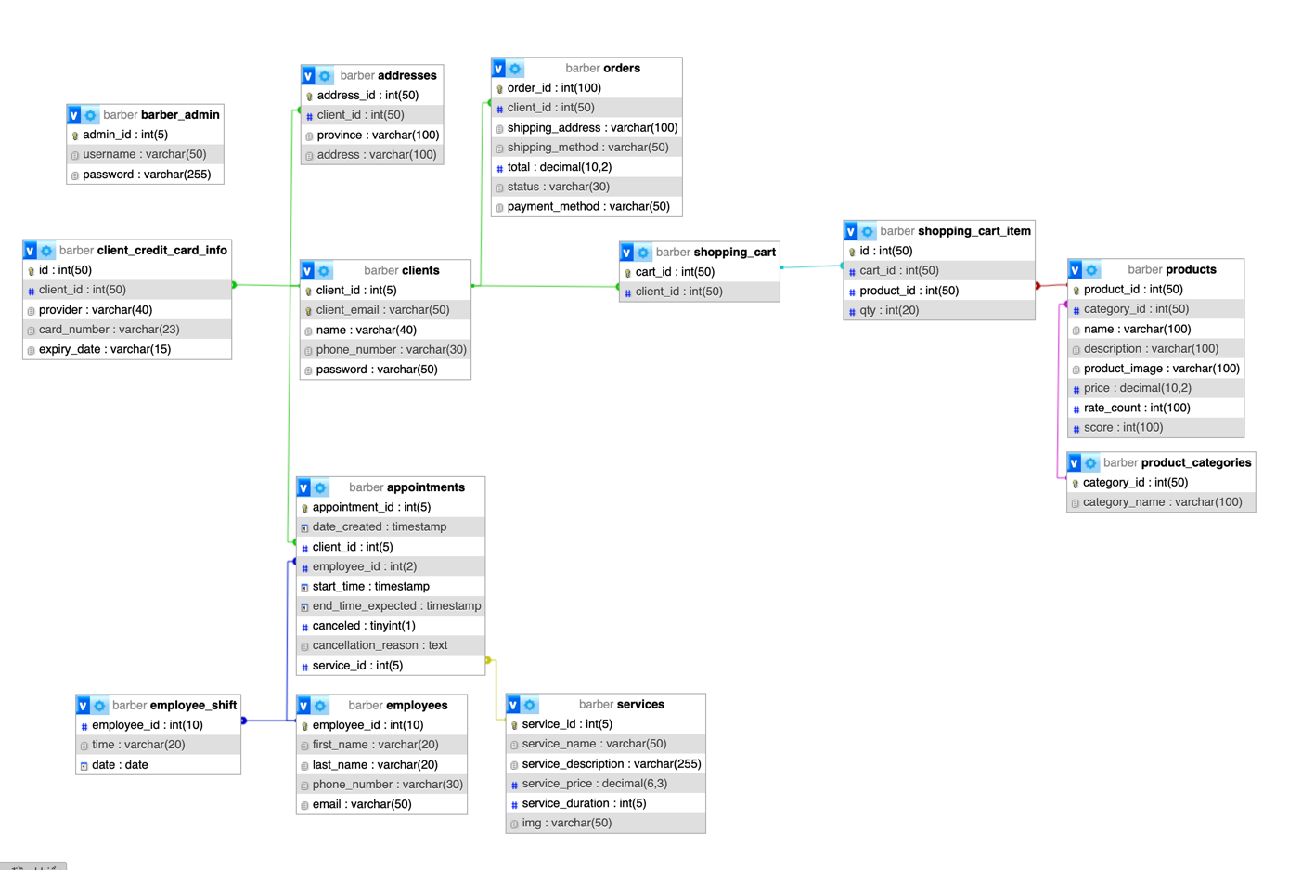

|  |
| --- |
| **SiteMap** |

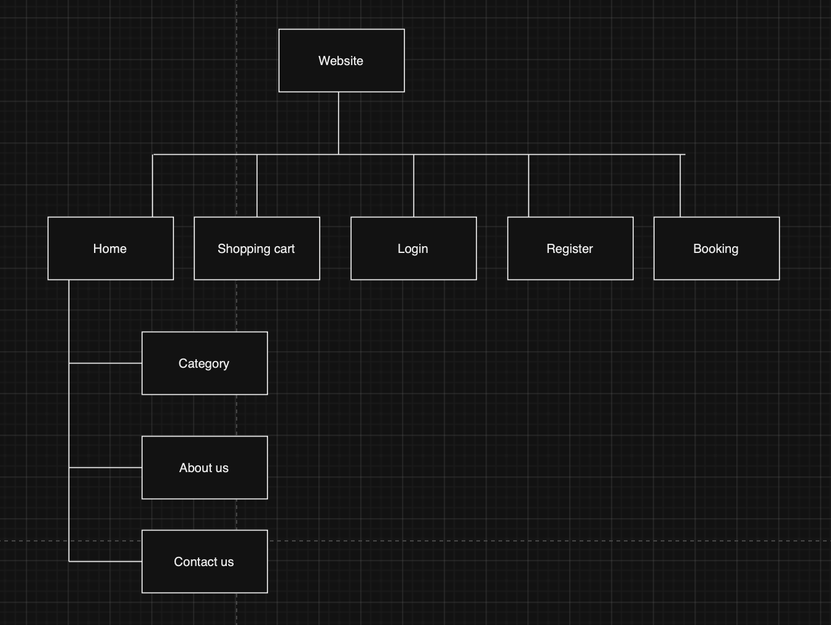

|  |
| --- |
| **Algorithm** |

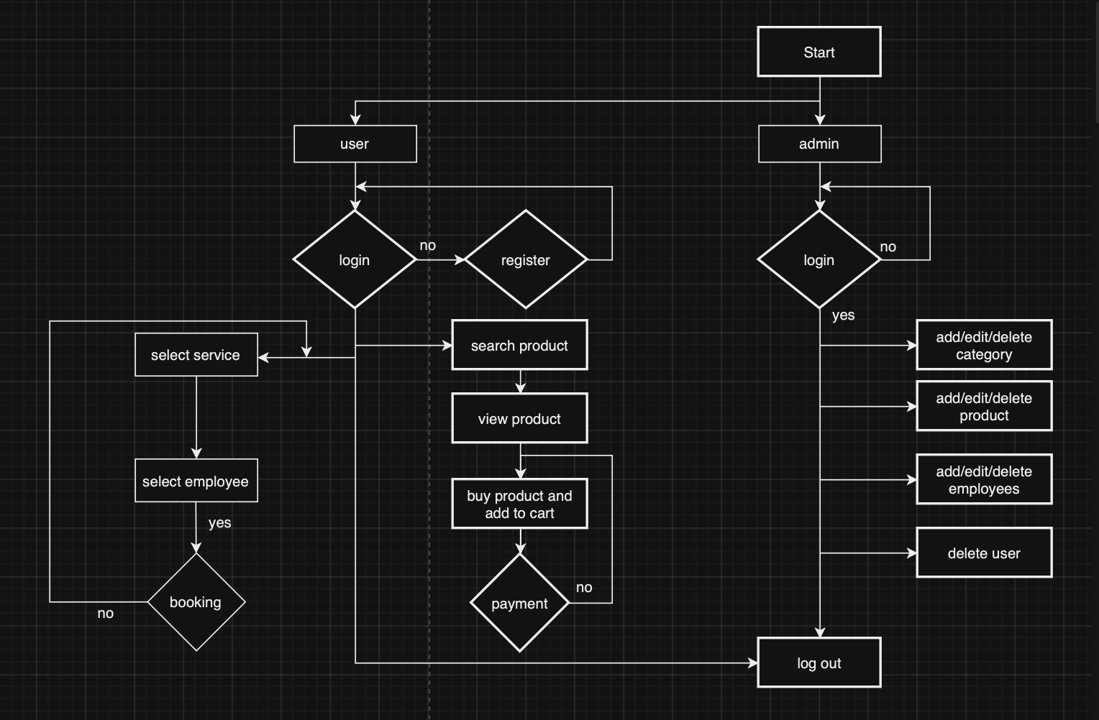

**Review 03**

|  |
| --- |
| **Screen shots** |

1. **Homepage:**

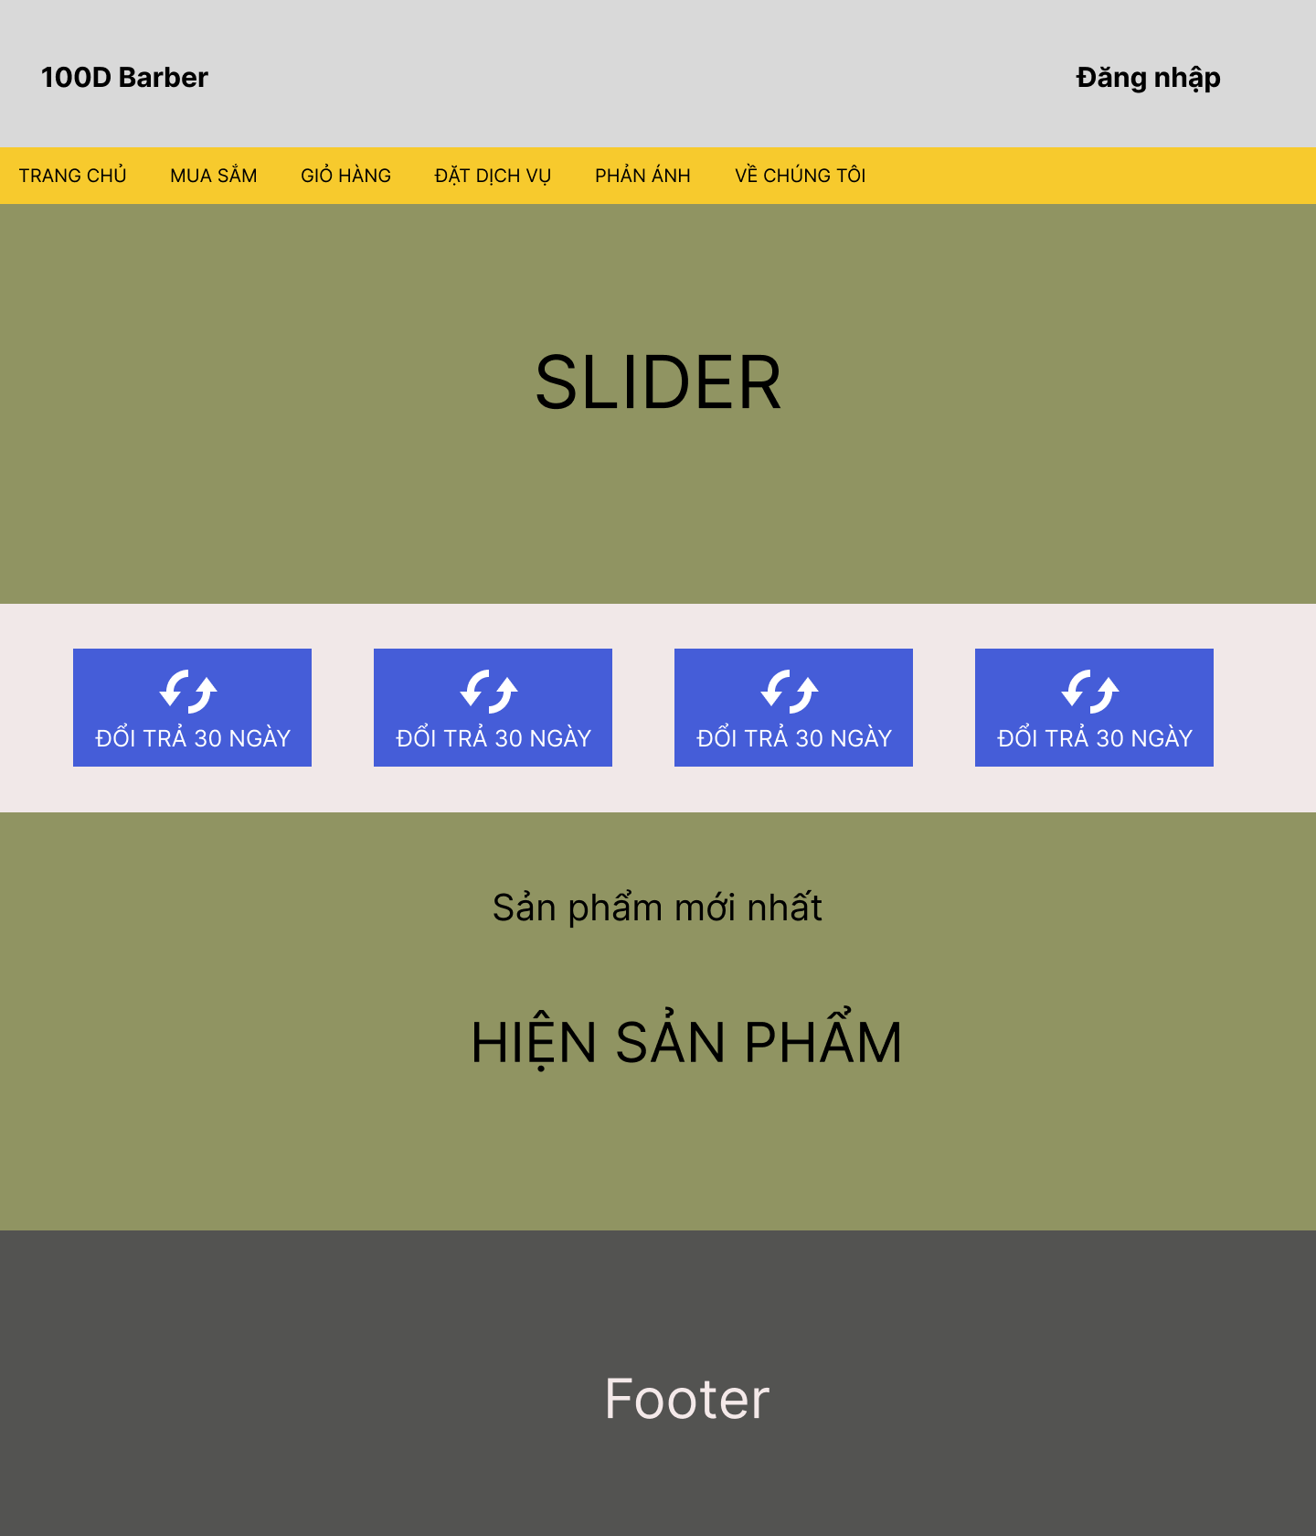

**Description** : Home page with navigation panel and login button

**From** : This is the index page

**To** : All other pages with the navigation panel

1. **Register page:**

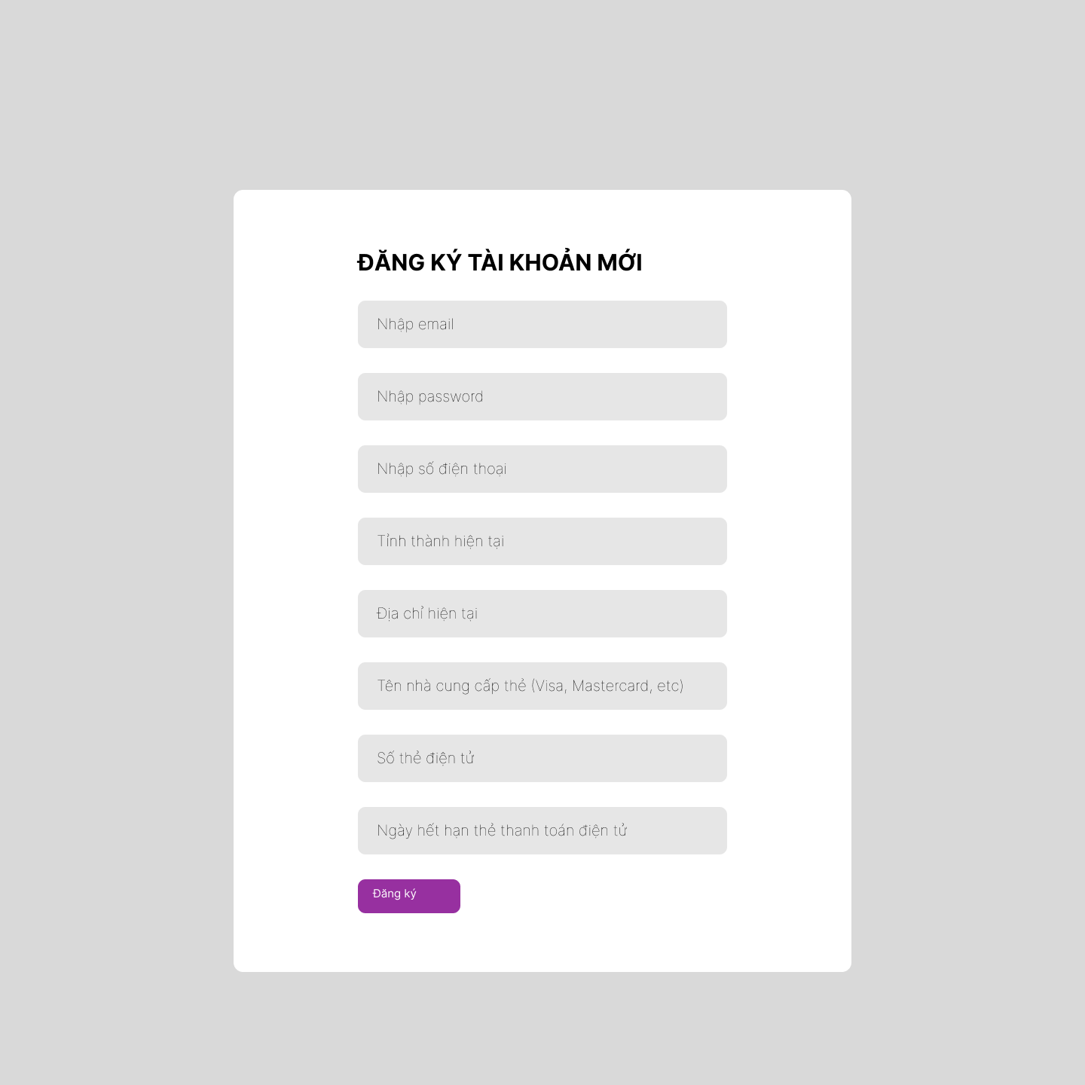

**Description** : Register a new account

**From** : Access from login page if not registered

**To** : Login page after creating an account

1. **Login page:**

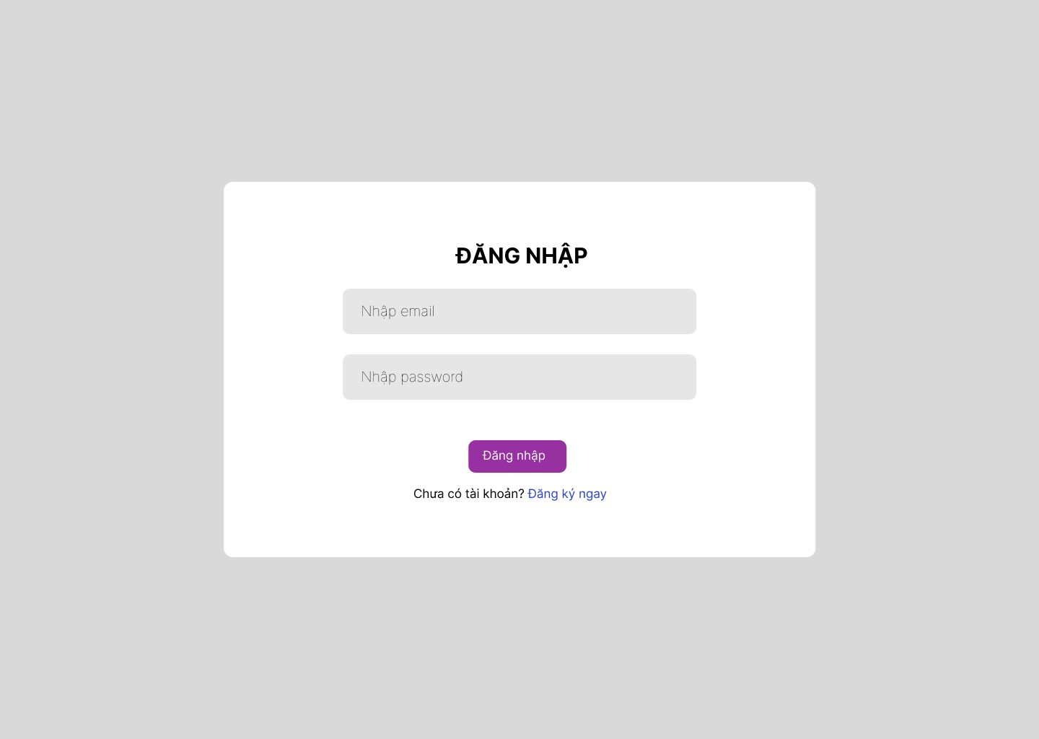

**Description** : Login to Homepage

**From** : Homepage if not logged-in

**To** : Homepage if log in successfully

1. **Shopping page:**

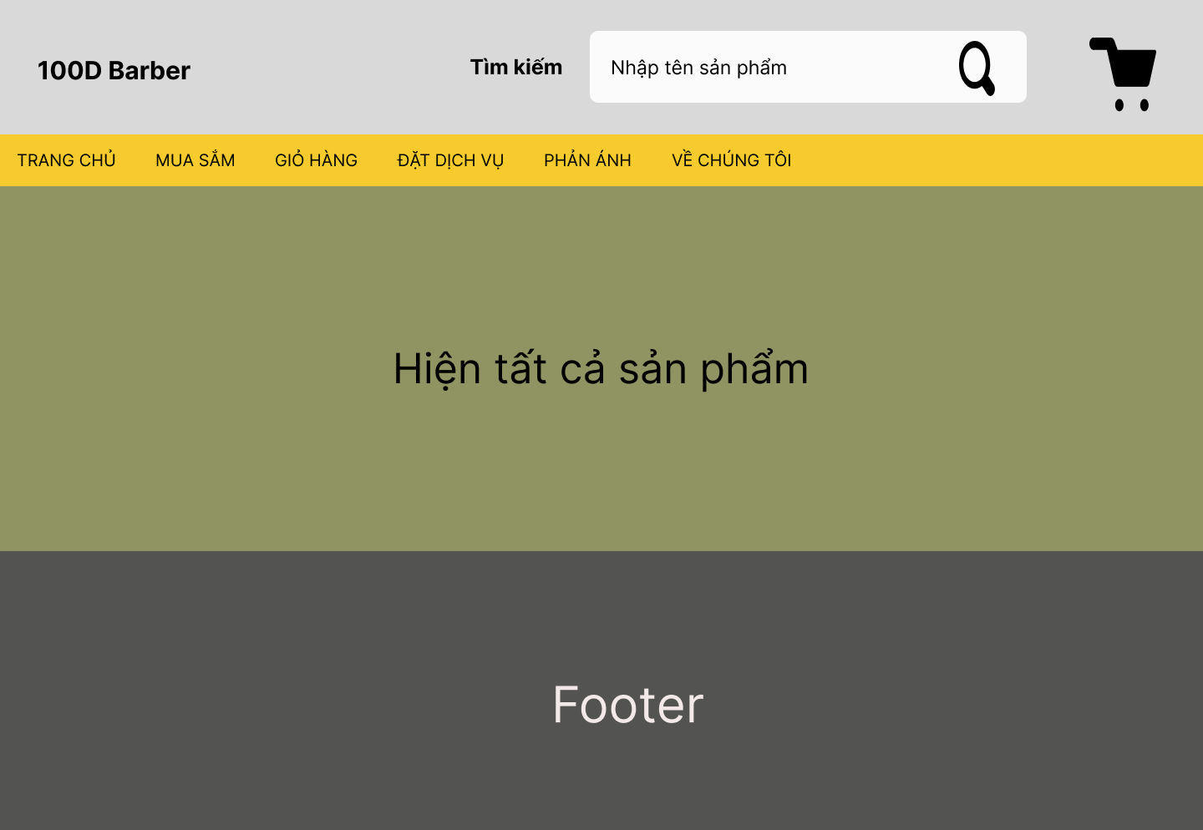

**Description** : Displaying all products for sale

**From** : Homepage

**To** : Can go to Cart_page as well as all other pages through the navigation panel

1. **Cart_page:**

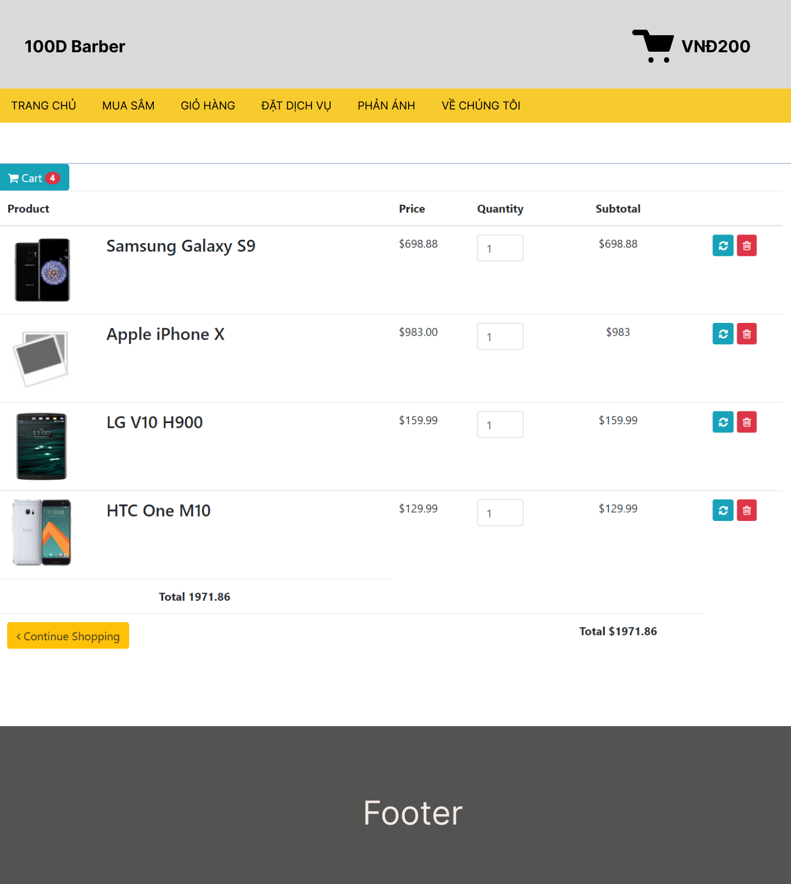

**Description** : Showing all selected product. User can add/change quantity/delete products

**From** : (1)Shopping_page by clicking the shopping cart icon or (2) through the navigation panel

**To** :

1. **Booking page:**

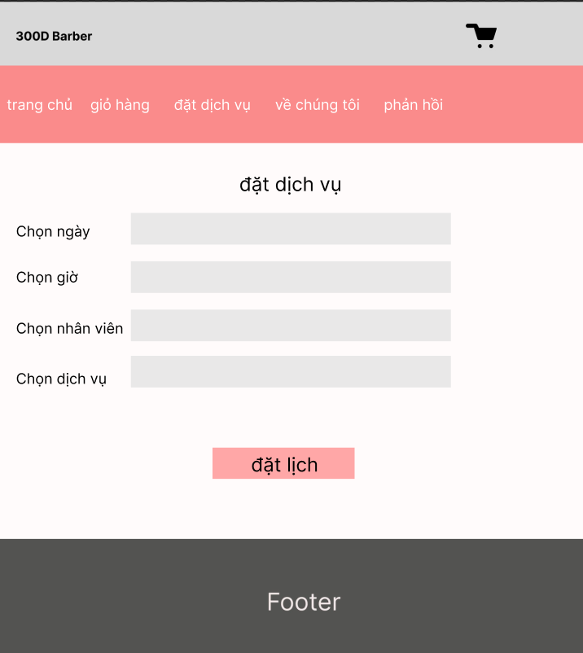

**Description** : Book hair cut services

**From** : Navigation panel

**To** :

|  |
| --- |
| **Testing document** |

|  |  |  |
| --- | --- | --- |
| **Sr.No** | **Features Tested** | **Remarks** |
| 1 | email | Required, unique, must be email format (xxx@xxx.xxx.xxx) |
| 2 | phone number | Required, digit only, less than 12 digits |
| 3 | province | Required |
| 4 | detail address | Required |
| 5 | card expiry date | Required, 4 digits only |
| 6 |  |  |

|  |
| --- |
| **Final checklist** |

|  |  |  |
| --- | --- | --- |
| **Sr.No** | **Aspected Tested** | **Suggestion/**  **Remarks** |
| 1 | Are all the users able to view the images and links? |  |
| 2 | Are the GUI content devoid of spelling mistakes? |  |
| 3 | Is the application user-friendly? |  |
| 4 | Is the Website launching correctly in all popular browsers? |  |
| 5 | Are all the forms validated with proper criteria? |  |
| 6 | Do all text links lead to the appropriate website? |  |
| 7 | Do all image links lead to the appropriate website? |  |
| 8 | Are all the images and links clearly visible on the page? |  |
| 9 | Does the Web page work properly in all the tested browsers? |  |
| 10 | Does the Web page take too long to be loaded fully? |  |
| 11 | Is the navigation sequences correct through all the Web pages on the site? |  |
| 12 | Is the JavaScript code working as expected in all click events? |  |
|  |  |  |

|  |  |  |  |  |  |  |  |  |
| --- | --- | --- | --- | --- | --- | --- | --- | --- |
| **No** | **Member** | **Contents** | | **Table Name** | **Activity Plan** | **Date of Preparation of Activity Plan** | | |
| **Planed Start Date** | **Actual Start Date** | **Actual Days** | **Status** |
| 1 | **Lý Khánh Hưng** | Admin | *Employees Management* | Appointments, Employees, Services, Employee_shift | 10/07/2023 | 11/07/2023 | 30 | OK |
| 2 | 10/07/2023 | 11/07/2023 | 30 | OK |
| 3 | User | *Booking* | 10/07/2023 | 11/07/2023 | 30 | OK |
| 4 | *Select services, employee* | 10/07/2023 | 11/07/2023 | 30 | OK |
|  |  |  |  |  |  |  |  |  |
| 1 | **Dương Tuấn Kiệt** | Admin | *Orders display* | Shopping_cart, Shopping_cart_item, Orders | 10/07/2023 | 11/07/2023 | 30 | OK |
| 2 | 10/07/2023 | 11/07/2023 | 30 | OK |
| 3 | 10/07/2023 | 11/07/2023 | 30 | OK |
| 4 | User | *Online shopping* | 10/07/2023 | 11/07/2023 | 30 | OK |
|  |  |  |  |  |  |  |  |  |
| 1 | **Phạm An Hào** | Admin | *Products Management* | Products, Product_category | 10/07/2023 | 11/07/2023 | 30 | OK |
| 2 | 10/07/2023 | 11/07/2023 | 30 | OK |
| 3 | User | *Products display* | 10/07/2023 | 11/07/2023 | 30 | OK |
| 4 | 10/07/2023 | 11/07/2023 | 30 | OK |
|  |  |  |  |  |  |  |  |  |
| 1 | **Trương Hoàng**  **Nguyên** | Admin | *Clients Management* | Clients, Addresses, Client_payment_methods | 10/07/2023 | 11/07/2023 | 30 | OK |
| 2 | 10/07/2023 | 11/07/2023 | 30 | OK |
| 3 | User | *Register, Login* | 10/07/2023 | 11/07/2023 | 30 | OK |
| 4 | *Update client information* | 10/07/2023 | 11/07/2023 | 30 | OK |